**East West University**

**Summer-2020**

**Course Code:** CSE301

**Course Title:** Database Systems

**Section:** 02

**Title of Use Case:** Formula 1 Championship

**Group Members: IDs:**

Moumita Chowdhury 2017-2-60-007

Anika Tabassum Nizhum 2017-2-60-052

**Submitted to:**

Dr. Mohammad Rezwanul Huq

Assistant Professor

Department of Computer Science and Engineering

**ER Model**

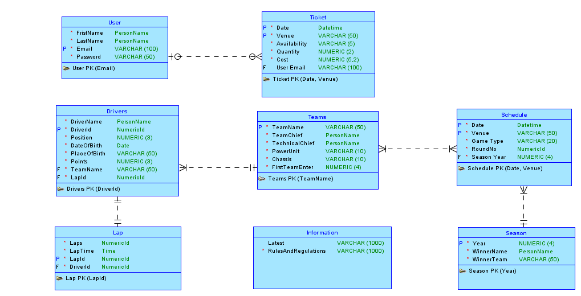

**Relational Data Model**

